**Mouse Wheel Set-up and Troubleshooting**

1. Open **Columbus Instruments Multi Device Software** (on the homepage, the blue C)
2. While opening, dialogue box saying “Manually Configure Port” should disappear shortly, as well as the following dialogue box. If these dialogue boxes don’t disappear, check troubleshooting issues.
3. Click on **Experiment**, and select **Run**.
4. When asked by the software “Want to use the default experiment template?” select **yes.**
5. When the next dialogue box appears, click on the three dots on the right side of box (see below).

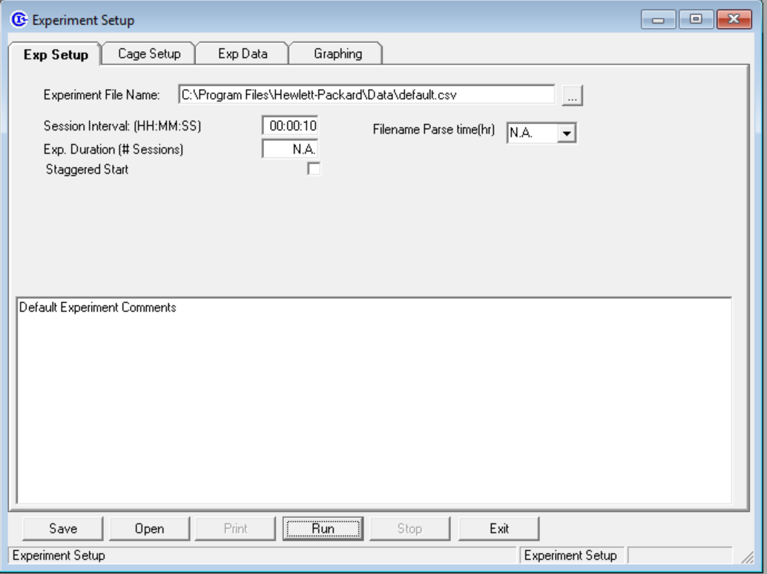

1. This will load the location for the wheel data to be saved, and once you find the appropriate folder for the mouse group (mouse group A, mouse group B, C…) change the file name to **Mouse group X Date 1 to Date 2,** and click **“open”.**
   1. For example, mice from group C starting on 1/24 will be saved as “Mouse Group C 1/24 to 1/25”. **Data should be checked every day.**
   2. The first letter on the mouse tag will be the group folder you save the data to.
2. Next, change **Session Interval** to **00:00:03**, which will allow the software to record every 3 seconds.
3. Click on the **Cage Setup** tab on the top of the screen after changing the interval.
4. Ensure all cages are switched to the blue text saying “**Enabled**”
5. Change each cage name to the corresponding mouse. For example, cage 1 could be mouse 473Cf. Each mouse tag should have what cage number they are on it (see below for examples).

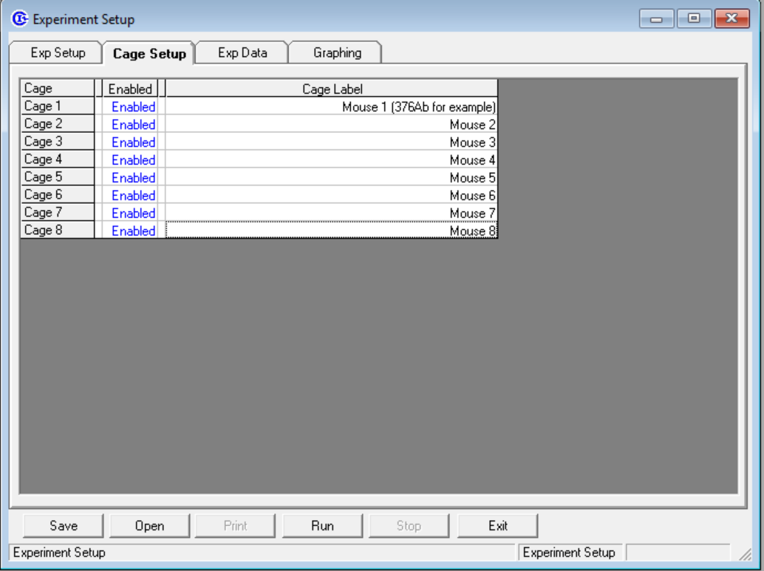

1. Once all of these steps are completed, click **Run**, and ensure data is being collected.

**Troubleshooting**

**“*Dialogue boxes aren’t disappearing when I load the software! The screen looks like this. What’s happening?!?!?*”**

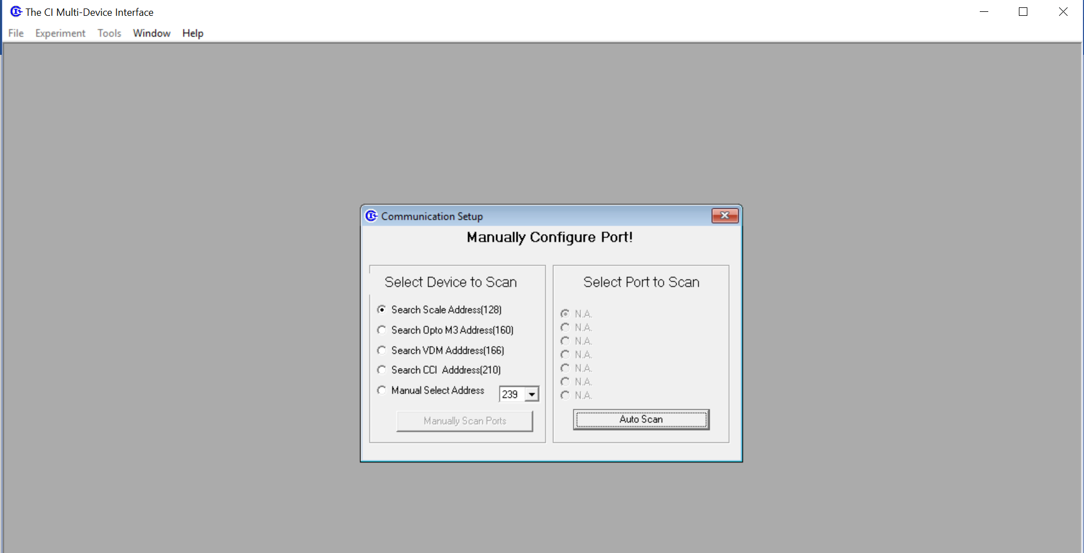

* Not a good error! The software isn’t picking up that the counter is collecting wheel data, so solutions include:
  + Replug USB into computer and ensure all wires are properly connected to all blue boxes.
  + Wheel counter is plugged in to the outlet, and both blue wires are connected into the same outlet (A outlet on the counter goes to the A outlet on the other box).
  + Close software, and try to reopen.
  + Call Eric

**“*The wheel count isn’t increasing when I test it?!?! What should I do??? I’m panicking!*”**

* First make sure the wires from the cages are all properly plugged into the correct box, and then refer to the steps above to make sure the computer is taking in data.
* Double check that there are no cuts in the wires, and that the dialogue boxes disappeared when you loaded up the software. If these don’t work, close the software, and reload it again, replacing the previous file name.

**These are the 2 most common issues, but if another arises, or the solutions posted don’t fix the problem - contact Austin**